**The Factory:**

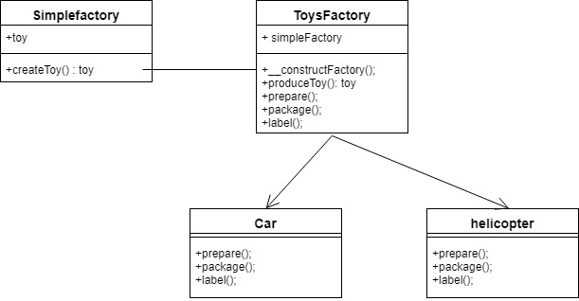

This to me is a way of creating objects. We have a factory class which given the input will output different objects. From the above example we see a customer walks into a toy shop factory knowing what it(customer) wants and only wants one object it then specifies and is returned the model it requests based on requirement.

The Abstract Factory:

This pattern creates families of related or dependant objects

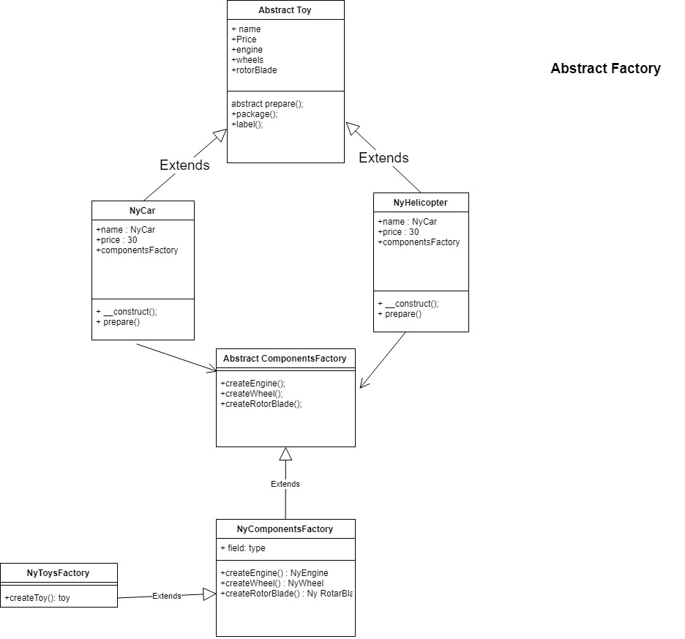

The Factory method patterns

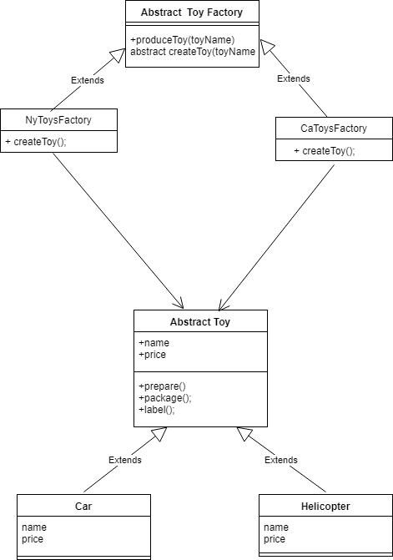

Let the subclass decide which class to instantiate.